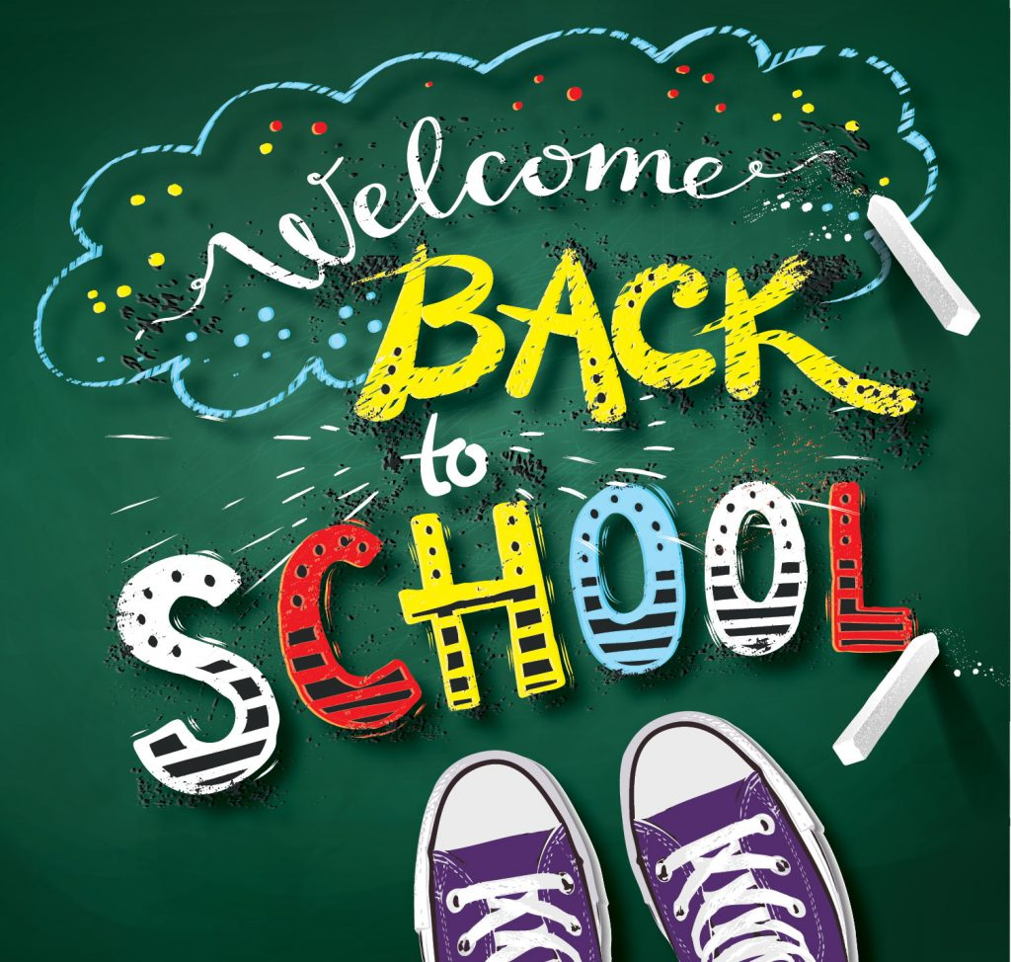

**Welcome to 2nd grade! My name is Serita Cahill. I will be your child’s teacher this school year! This is a year of important transitions, as well as gaining new skills. I hope to make your child’s learning experience a fun and exciting one, and hope to instill a love of learning. This year will be full of important transitions. It is tremendously important to keep in mind that we all build on small successes. Each child will progress at his/her own rate, acquiring skills as he/she is developmentally ready. Maintaining each child’s self-esteem and building secure foundation for future growth will always remain a priority throughout the year. Celebrate your child’s success, no matter how small it may seem. This will keep your child enthusiastic about learning and proud of their work!**

**I am looking forward to working with you and your child this year, and helping him/her to achieve his/her full potential.**

**Parent/Teacher Communication:**

**I believe that a good parent-teacher relationship is necessary for maximum school success. Throughout the year I will communicate with you through emails, texts, CLASS DOJO, notes, progress reports, report cards, and parent-teacher conferences. I encourage you to contact me if you have any concern or questions at any time. You can call me at school 314-214-8255, email** [**serita.cahill@slps.org**](mailto:serita.cahill@slps.org) **or CLASS DOJO.**

**Sincerely,**

**Ms. Cahill**